**LAB MANUAL 4: -**

MUHAMMAD SHEHRYAR ISMAIL 461599

ME 15 SECTION A

**TASK 1: -**

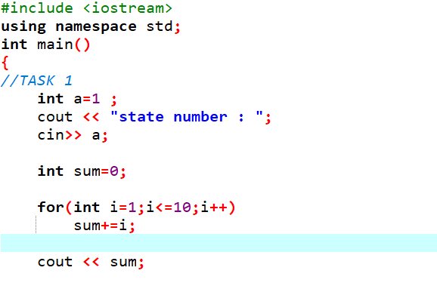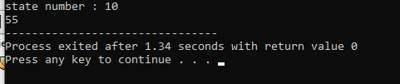

**TASK 2: -**

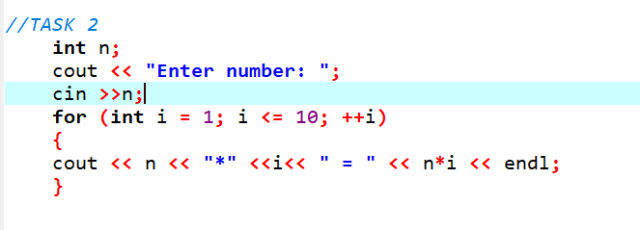

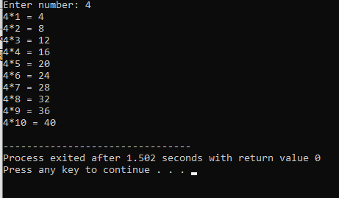

**TASK 3: -**

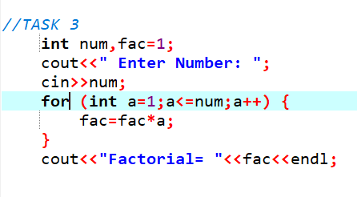

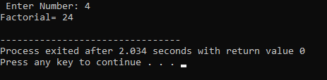

**TASK 4: -**

